Constructing Line Segment

Definition
# Source: AI Source: Provided by: [Data Path: Persons Table -> ID Column: 1, Name_En Column: Motasem Essam] -> From: [ChatGPT] on [7/25/2026]
Constructing a line segment is a geometric construction in which a line segment of a specified length is created using exact geometric methods.
A line segment is the part of a line bounded by two endpoints.
For endpoints $A$and $B$, the constructed segment is:
$$\boxed{\overset{‾}{AB}}$$
Its length is:
$$\boxed{AB}$$
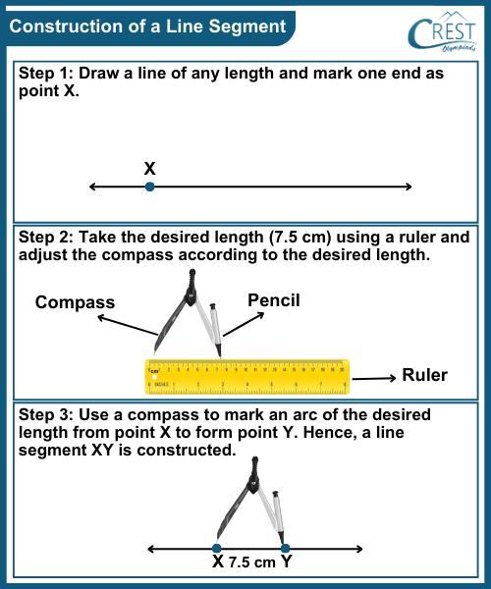
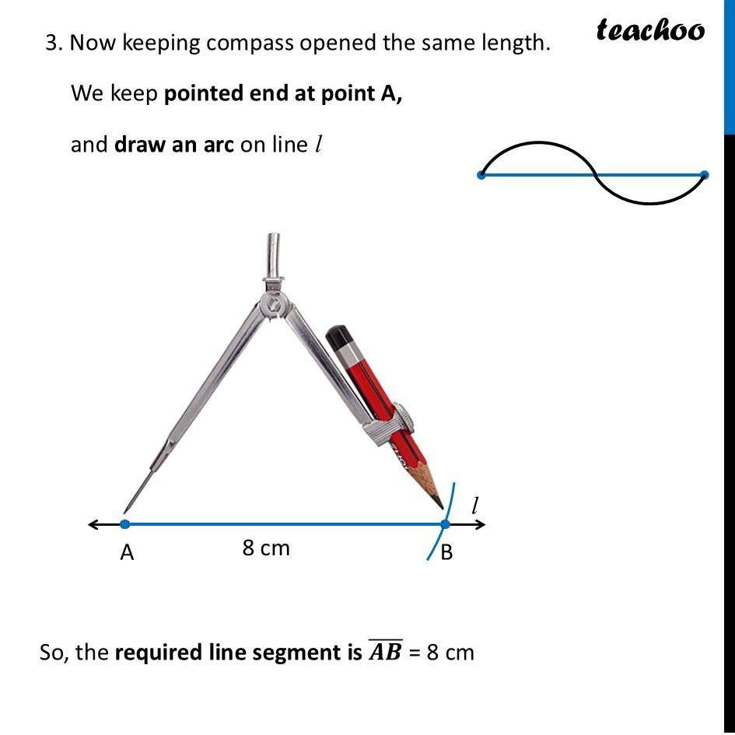
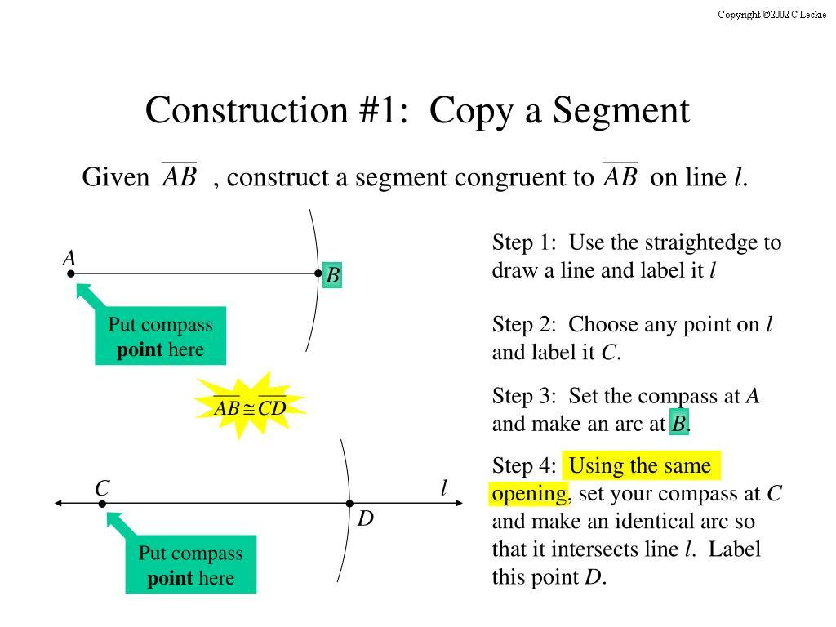
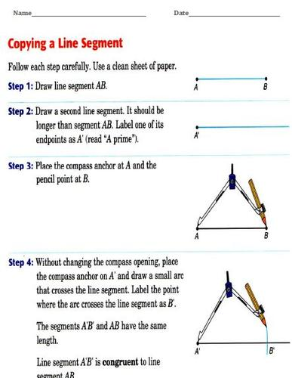
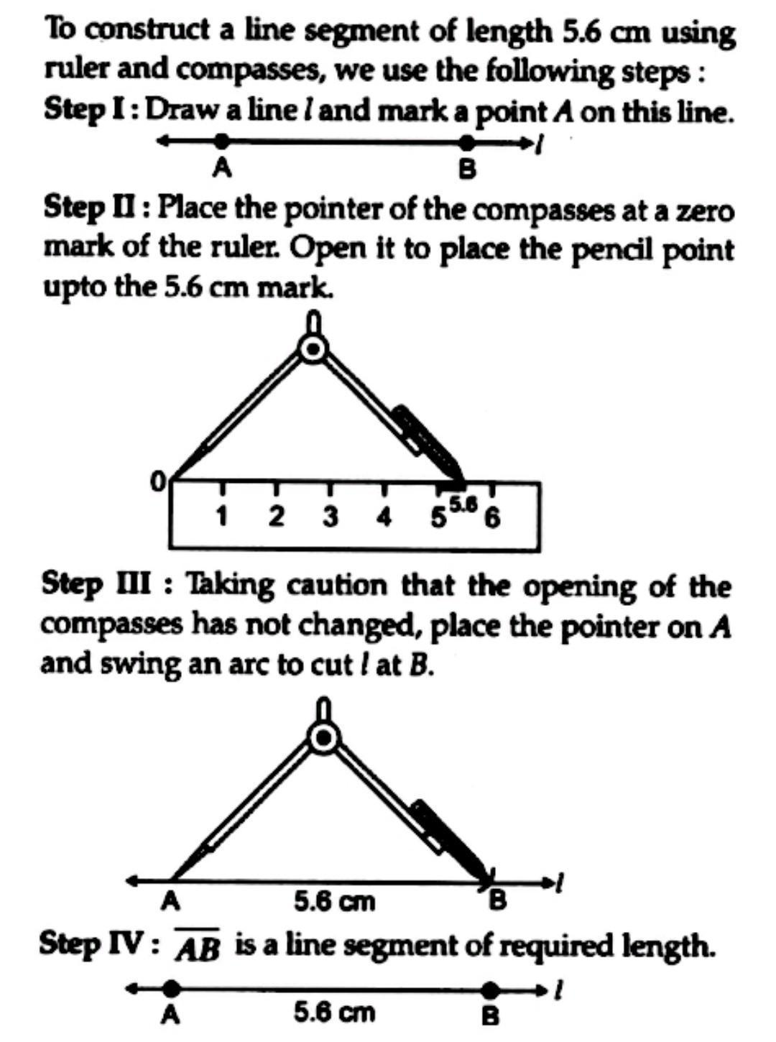

Fundamental Concept
# Source: AI Source: Provided by: [Data Path: Persons Table -> ID Column: 1, Name_En Column: Motasem Essam] -> From: [ChatGPT] on [7/25/2026]
A line segment can be constructed in two common situations:
- Constructing a segment between two given points
- Constructing a segment with a given length
The first requires only a straightedge.
The second traditionally uses a compass and straightedge to transfer the required length accurately.

1. Constructing a Line Segment Between Two Given Points
# Source: AI Source: Provided by: [Data Path: Persons Table -> ID Column: 1, Name_En Column: Motasem Essam] -> From: [ChatGPT] on [7/25/2026]
Suppose two points $A$and $B$are given:
$$A∙ ∙B$$
Using a straightedge, draw the straight line connecting them:
$$\boxed{\overset{‾}{AB}}$$
Construction Steps
- Identify the two given points $A$and $B$.
- Place the straightedge so that it passes through both points.
- Draw the straight line through $A$and $B$.
- The portion between $A$and $B$is the required line segment.
Result
$$\boxed{\overset{‾}{AB}}$$
with length:
$$\boxed{AB}$$

2. Constructing a Line Segment of a Given Length
# Source: AI Source: Provided by: [Data Path: Persons Table -> ID Column: 1, Name_En Column: Motasem Essam] -> From: [ChatGPT] on [7/25/2026]
Suppose a segment of length $L$must be constructed from a given starting point $A$.
For example, construct:
$$AB=L$$
Construction Steps
- Start with the given point $A$.
- Use a compass to set its opening equal to the required length $L$.
- Keep the compass opening fixed.
- Choose the direction in which the segment will be constructed.
- Mark a point $B$at the compass distance from $A$.
- Draw the segment $\overset{‾}{AB}$.
Therefore:
$$\boxed{AB=L}$$
The compass ensures that the constructed segment has the required length.

3. Copying a Given Line Segment
# Source: AI Source: Provided by: [Data Path: Persons Table -> ID Column: 1, Name_En Column: Motasem Essam] -> From: [ChatGPT] on [7/25/2026]
Another important construction is copying an existing segment.
Suppose:
$$\overset{‾}{AB}$$
is given, and we need to construct an equal segment beginning at $C$.
Required:
$$\boxed{CD=AB}$$
Construction Steps
- Given the original segment $\overset{‾}{AB}$.
- Open the compass so that its endpoints touch $A$and $B$.
- Do not change the compass opening.
- Place one end of the compass at $C$.
- Draw an arc intersecting the chosen ray from $C$.
- Label the intersection $D$.
- Draw $\overset{‾}{CD}$.
Therefore:
$$\boxed{CD=AB}$$
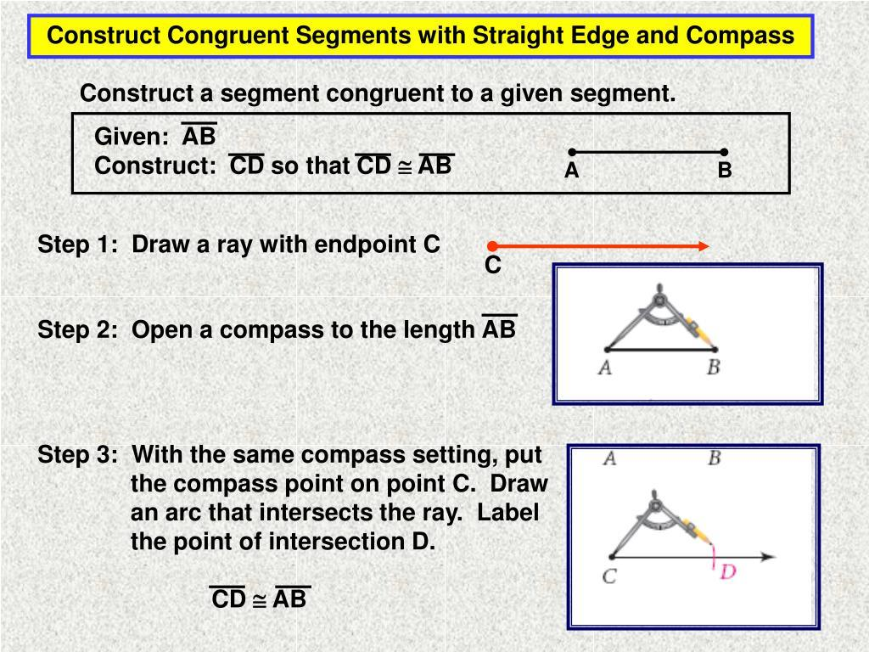
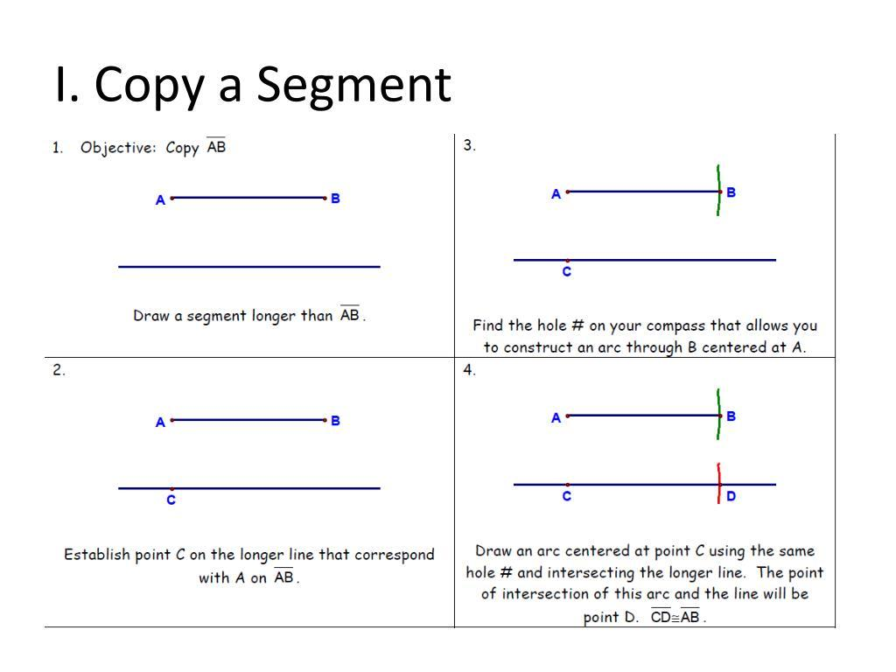

Main Characteristics
# Source: AI Source: Provided by: [Data Path: Persons Table -> ID Column: 1, Name_En Column: Motasem Essam] -> From: [ChatGPT] on [7/25/2026]
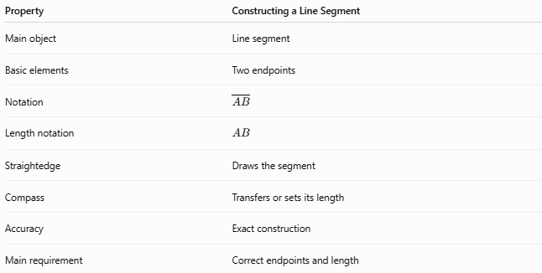
Property | Constructing a Line Segment
Main object | Line segment
Basic elements | Two endpoints
Notation | $$\overset{‾}{AB}$$
Length notation | $$AB$$
Straightedge | Draws the segment
Compass | Transfers or sets its length
Accuracy | Exact construction
Main requirement | Correct endpoints and length

Important Distinction
# Source: AI Source: Provided by: [Data Path: Persons Table -> ID Column: 1, Name_En Column: Motasem Essam] -> From: [ChatGPT] on [7/25/2026]
A line, line segment, and ray are different geometric objects.
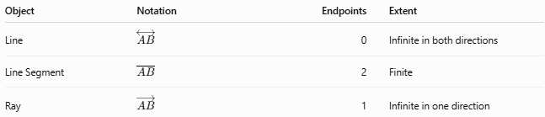
Object | Notation | Endpoints | Extent
Line | $$\overset{↔}{AB}$$ | 0 | Infinite in both directions
Line Segment | $$\overset{‾}{AB}$$ | 2 | Finite
Ray | $$\vec{AB}$$ | 1 | Infinite in one direction
Therefore, constructing $\overset{‾}{AB}$means constructing only the finite portion between $A$and $B$.

Relationship to Other Constructions
# Source: AI Source: Provided by: [Data Path: Persons Table -> ID Column: 1, Name_En Column: Motasem Essam] -> From: [ChatGPT] on [7/25/2026]
Constructing a line segment is a basic geometric construction and is used as a foundation for many other constructions.
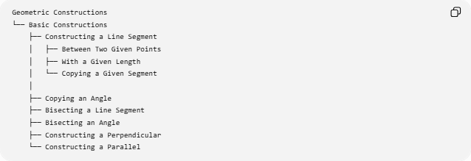
Geometric Constructions
└── Basic Constructions
├── Constructing a Line Segment
│ ├── Between Two Given Points
│ ├── With a Given Length
│ └── Copying a Given Segment
│
├── Copying an Angle
├── Bisecting a Line Segment
├── Bisecting an Angle
├── Constructing a Perpendicular
└── Constructing a Parallel
For example, constructing a perpendicular bisector requires a given line segment first:
$$\overset{‾}{AB}$$
Then the segment is bisected to locate its midpoint.

Key Formulas and Relationships
# Source: AI Source: Provided by: [Data Path: Persons Table -> ID Column: 1, Name_En Column: Motasem Essam] -> From: [ChatGPT] on [7/25/2026]
For a constructed segment:
$$\boxed{\overset{‾}{AB}}$$
its length is:
$$\boxed{AB}$$
If it is copied:
$$\boxed{CD=AB}$$
If a segment is divided at its midpoint $M$:
$$\boxed{AM=MB}$$
and:
$$\boxed{AB=AM+MB}$$

Example
# Source: AI Source: Provided by: [Data Path: Persons Table -> ID Column: 1, Name_En Column: Motasem Essam] -> From: [ChatGPT] on [7/25/2026]
Suppose the required segment has length:
$$AB=6\text{ cm}$$
To construct it:
- Mark point $A$.
- Set the compass opening to $6\text{ cm}$.
- Mark point $B$at that distance from $A$.
- Draw $\overset{‾}{AB}$.
Result:
$$\boxed{AB=6\text{ cm}}$$
If instead a given segment has length $6\text{ cm}$, the compass can transfer that exact length to another location.

Classification Summary
# Source: AI Source: Provided by: [Data Path: Persons Table -> ID Column: 1, Name_En Column: Motasem Essam] -> From: [ChatGPT] on [7/25/2026]
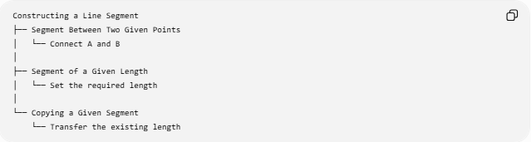
Constructing a Line Segment
├── Segment Between Two Given Points
│ └── Connect A and B
│
├── Segment of a Given Length
│ └── Set the required length
│
└── Copying a Given Segment
└── Transfer the existing length

Key Points
# Source: AI Source: Provided by: [Data Path: Persons Table -> ID Column: 1, Name_En Column: Motasem Essam] -> From: [ChatGPT] on [7/25/2026]
- A line segment has exactly two endpoints.
- It is represented by:
$$\boxed{\overset{‾}{AB}}$$
- Its length is represented by:
$$\boxed{AB}$$
- A straightedge can connect two given points.
- A compass can set or transfer a required length.
- Copying a segment means constructing another segment with exactly the same length.
- Constructing line segments is a fundamental construction used in many more advanced geometric constructions.

Conclusion
# Source: AI Source: Provided by: [Data Path: Persons Table -> ID Column: 1, Name_En Column: Motasem Essam] -> From: [ChatGPT] on [7/25/2026]
Constructing a Line Segment is one of the most basic types of geometric construction. It involves creating a finite straight path between two endpoints or reproducing a specified length exactly. The straightedge establishes the straight path, while the compass can establish or transfer the required distance.
$$\boxed{\text{Constructing a Line Segment}=\text{Creating an exact finite segment of a specified or transferred length}}$$

